Group symbol: 3
Team: 1

Project title: Resource Allocation App

Team members (filled by PM, Team Leader):
No | Name | Surname | Student ID | Role
1 | Carmelo Aidan | Romero | 293936 | PM, Team Leader
2 | Álvaro | Puebla | 293867 | Team member
3 | David | Sosa | 293885 | Team member
4 | Diego | Ceballos | 293943 | Team member
5 | Diego | García | 293939 | Team member
6 | Óscar | López | 293871 | Team member

Construction and tests (S4)

Implementation
The documentation focuses on the implementation of the software in the form of programming language source codes. You should prepare lists of created artefacts, i.e., source codes, configuration files, files containing program resources, pre-requirements, and result programs. You should supplement the list of artefacts with a description indicating the relationships between them and their nature (type), as well as technical requirements in the scope of their use. The implementation should cover the minimum viable product (MVP) of the system.
The presentation of the application execution is a must for obtaining a positive grade.

4.1.1. Overview
This section documents the implementation of the Resource Management System MVP (Minimum Viable Product). The system is a web-based application built using Spring Boot, following a layered architecture pattern with clear separation of concerns.

4.1.2. Technology Stack
Backend:
- Java 21
- Spring Boot 3.3.3
- Spring Data JPA (Hibernate)
- Spring Security
- Spring Validation
- MySQL 8
Frontend:
- Thymeleaf (server-side templating)
- HTML5/CSS3
- JavaScript (ES6+)
Build & Deployment:
- Gradle 8.x
- Docker & Docker Compose
- Nginx (reverse proxy)
- Let's Encrypt (SSL/TLS)
Testing:
- JUnit 5
- Mockito
- Spring Boot Test
- Spring Security Test

4.1.3. Artifacts List

A. Source Code Artifacts
Entity Layer (src/main/java/.../entity/)
File | Type | Description | Dependencies
User.java | Abstract Entity | Base class for all users; contains common fields (name, email, password, accountStatus) | JPA, Validation, Lombok
Client.java | Entity | Extends User; represents library clients with reservation limits | User.java
Admin.java | Entity | Extends User; represents system administrators | User.java
Resource.java | Abstract Entity | Base class for reservable resources | JPA, Lombok
Book.java | Entity | Extends Resource; represents library books | Resource.java
Room.java | Entity | Extends Resource; represents reservable rooms | Resource.java
Reservation.java | Entity | Represents resource reservations with composite key | Resource, Client, Admin
ReservationId.java | Embeddable | Composite primary key for Reservation (resourceId, endTime) | JPA
AccountStatus.java | Enum | User account states (ACTIVE, SUSPENDED, BLOCKED, PENDING) | -
EndAfterStart.java | Annotation | Custom validation constraint | Validation
EndAfterStartValidator.java | Validator | Validates end time > start time | EndAfterStart
Repository Layer (src/main/java/.../repository/)
File | Type | Description | Dependencies
UserRepository.java | Interface | CRUD + findByEmail | Spring Data JPA
ClientRepository.java | Interface | Client-specific queries | UserRepository
AdminRepository.java | Interface | Admin-specific queries | UserRepository
ResourceRepository.java | Interface | Base resource operations | Spring Data JPA
BookRepository.java | Interface | Book queries (findByIsbn) | ResourceRepository
RoomRepository.java | Interface | Room queries (findByRoomCode) | ResourceRepository
ReservationRepository.java | Interface | Complex reservation queries (overlaps, availability) | Spring Data JPA

Service Layer (src/main/java/.../service/)
File | Type | Description | Dependencies
UserService.java | Service | User management (CRUD, blocking, authentication prep) | Repositories, PasswordEncoder
ResourceService.java | Service | Resource management (CRUD, availability checking) | Repositories
ReservationService.java | Service | Reservation logic (creation, validation, cancellation) | Repositories
QRService.java | Service | QR code decoding using ZXing library | ZXing

Security Layer (src/main/java/.../security/)
File | Type | Description | Dependencies
SecurityConfig.java | Configuration | Spring Security setup (authentication, authorization, CSRF) | Spring Security
JpaUserDetailsService.java | Service | UserDetailsService implementation for authentication | UserRepository, Spring Security
UserValidationFilter.java | Filter | Validates user status on each request (blocks deleted/suspended users) | UserRepository

Controller Layer (src/main/java/.../controller/)
File | Type | Description | Dependencies
HomeController.java | Controller | Main page, login, resource filtering | Services
ResourceController.java | Controller | Resource details, reservations (client-facing) | Services
AdminController.java | Controller | Admin dashboard (user, resource, reservation management) | Services
ScannerController.java | Controller | QR code scanning functionality | QRService, ResourceService
MyErrorController.java | Controller | Custom error page handling | -

Web Forms (src/main/java/.../web/)
File | Type | Description | Dependencies
UserForm.java | DTO | User creation/editing form | Validation
ResourceForm.java | DTO | Resource creation/editing form (polymorphic Book/Room) | Validation
ReservationForm.java | DTO | Client reservation form | Validation, EndAfterStart
AdminReservationForm.java | DTO | Admin reservation form (includes clientId) | Validation, EndAfterStart

Application Entry
File | Type | Description
ResourceManagementApplication.java | Main Class | Spring Boot application entry point

B. Configuration Files
File | Type | Description | Used By
application.properties | Config | Database, JPA, logging, security settings | Spring Boot
build.gradle | Build | Gradle dependencies and build configuration | Gradle
settings.gradle | Build | Project settings | Gradle
docker-compose.yml | Deployment | Container orchestration (nginx, MySQL, backend, certbot) | Docker
Dockerfile | Deployment | Backend container definition | Docker
nginx/conf.d/resourcemanagement.conf | Config | Nginx reverse proxy configuration | Nginx
nginx/start.sh | Script | Dynamic nginx configuration (HTTP/HTTPS switching) | Nginx
mysql/conf/my.cnf | Config | MySQL performance tuning | MySQL
setup-https.sh | Script | Automated SSL certificate acquisition | Certbot

C. Resource Files
Database Initialization
File | Type | Description
src/main/resources/init/data.sql | SQL | Initial data (admin user, client user, sample resources)
src/test/resources/init/data.sql | SQL | Test data for integration tests

Templates (src/main/resources/templates/)
File | Type | Description
layout.html | Template | Master layout with header, footer, navigation
index.html | Template | Main resource browsing page
login.html | Template | Login form
resource.html | Template | Resource detail and reservation page
reservation-edit.html | Template | Client reservation editing
scan.html | Template | QR code scanner interface
error.html | Template | Error page
admin/dashboard.html | Template | Admin overview
admin/resources.html | Template | Resource management table
admin/resource_form.html | Template | Resource creation/editing
admin/user_form.html | Template | User creation
admin/reservation_form.html | Template | Admin reservation creation
admin/reservation_edit.html | Template | Admin reservation editing

Static Resources
Path | Type | Description
static/css/*.css | Stylesheet | 11 CSS files for styling (variables, layout, components)
static/js/*.js | JavaScript | 5 JS files for client-side behavior
static/img/WUST.png | Image | University logo

Test Resources (src/test/resources/)
File | Type | Description
application.properties | Config | Test database configuration
static/img/validqr.png | Image | Valid QR code for testing
static/img/notvalidqr.png | Image | Invalid QR code for testing

D. Test Artifacts
Unit Tests (13 test classes)
File | Coverage | Test Count
EndAfterStartValidatorTest.java | Entity validation | 8 tests
EntityValidationTest.java | Entity constraints | 8 tests
QRServiceTest.java | QR code decoding | 6 tests
UserServiceTest.java | User management | 6 tests
ResourceServiceTest.java | Resource operations | 5 tests
ReservationServiceTest.java | Reservation logic | 6 tests

Integration Tests
File | Coverage | Test Count
RepositoryIntegrationTest.java | Database layer | 8 tests
FullIntegrationTest.java | End-to-end workflows | 7 tests

Controller Tests (MockMvc)
File | Coverage | Test Count
AdminControllerTest.java | Admin endpoints | 11 tests
HomeControllerTest.java | Public pages | 8 tests
ResourceControllerTest.java | Resource operations | 5 tests
ScannerControllerTest.java | QR scanning | 6 tests

Security Tests
File | Coverage | Test Count
SecurityConfigTest.java | Authentication & authorization | 10 tests

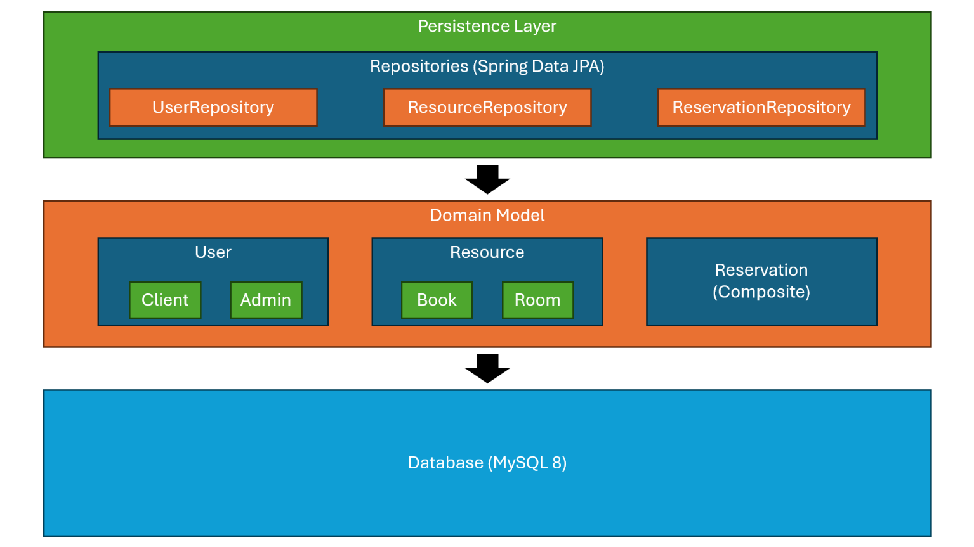
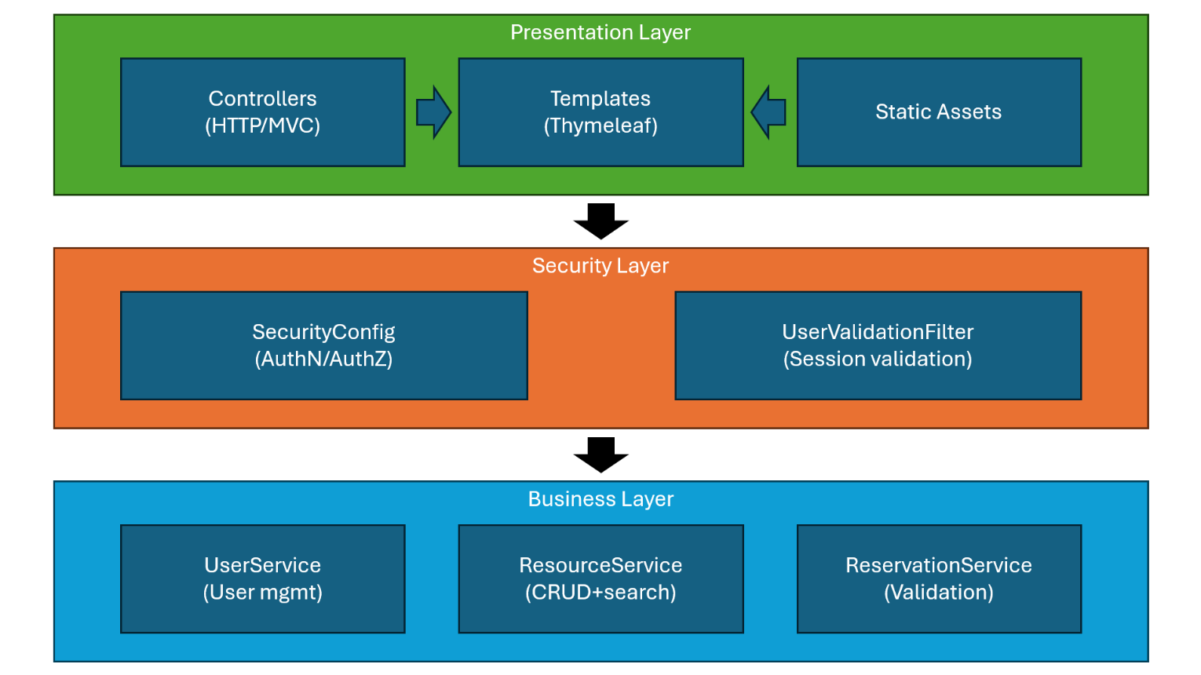
4.1.4. Architecture & Relationships
Key Relationships:
- Inheritance: User → Client/Admin, Resource → Book/Room (JOINED strategy)
- Composition: Reservation embeds ReservationId (composite key: resourceId + endTime)
- Associations:
  - Reservation → Resource (ManyToOne, part of PK)
  - Reservation → Client (ManyToOne, required)
  - Reservation → Admin (ManyToOne, optional - set when admin creates reservation)

4.1.5. Technical Requirements
Prerequisites:
- Java: JDK 21 or higher
- Gradle: 8.x (wrapper included)
- Docker: 20.x or higher
- Docker Compose: v2.x or higher
- MySQL: 8.0 (via Docker or local)
- Modern Browser: Chrome/Firefox/Edge (for client UI)

Build & Run:
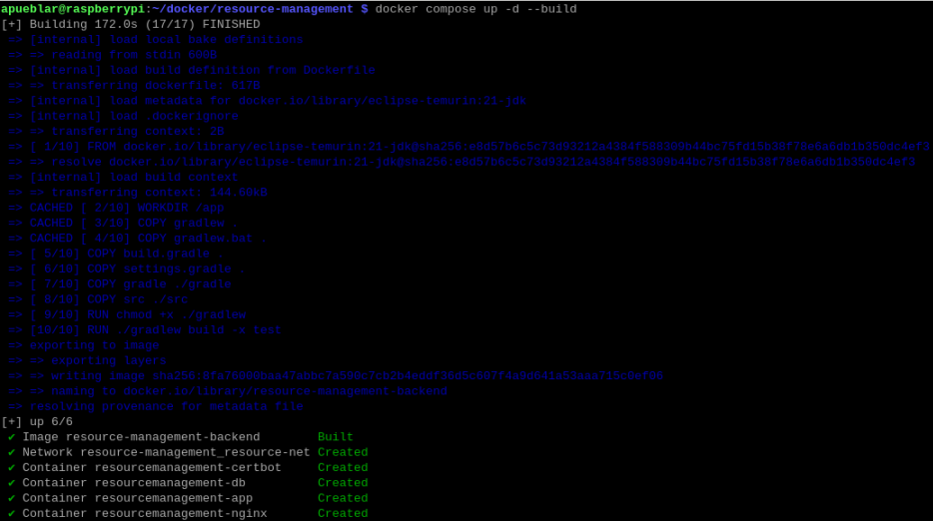
docker compose up -d –build

# Run tests
./gradlew test

# SSL certificate setup (production)
./setup-https.sh

Environment Variables:
SPRING_DATASOURCE_URL=jdbc:mysql://mysql:3306/resourcemanagement
SPRING_DATASOURCE_USERNAME=app_user
SPRING_DATASOURCE_PASSWORD=strongpassword
SPRING_JPA_HIBERNATE_DDL_AUTO=update
Ports:
- 80 - HTTP (redirects to HTTPS in production)
- 443 - HTTPS (production)
- 8080 - Spring Boot (internal)
- 3306 - MySQL (internal)

4.1.6. MVP Feature Coverage
Feature | Artifacts | Status
User Authentication | SecurityConfig, JpaUserDetailsService, UserValidationFilter | ✅ Complete
User Management | UserService, AdminController, Client/Admin entities | ✅ Complete
Resource Browsing | HomeController, ResourceService, index.html | ✅ Complete
Resource Management | ResourceService, AdminController, Book/Room entities | ✅ Complete
Reservation System | ReservationService, Reservation entity, validation | ✅ Complete
QR Code Scanning | QRService, ScannerController, ZXing library | ✅ Complete
Admin Dashboard | AdminController, admin templates | ✅ Complete
Time-based Filtering | HomeController, ReservationRepository queries | ✅ Complete

Tests
The documentation should cover the methods and test results of the specific system’s element both from the functional and non-functional point of view. The scope and the description should conform to the specification of the requirements (F2). You should include a description of at least one test of each type of requirement (e.g. business logic, user interface, data exchange, etc.).
    - Requirements Tests
In this section, you should differentiate the description of tests from manual and automated tests. You should include scripts or test case scenarios in the report.
      - Functional requirements tests
FR-01: User Authentication
Test ID | Test Name | Type | Status
FR01-001 | Valid login redirects to main page | Automated (Integration) | ✅ Pass
FR01-002 | Invalid credentials show error | Automated (Integration) | ✅ Pass
FR01-003 | Blocked users cannot login | Automated (Integration) | ✅ Pass

Test Case: FR01-001
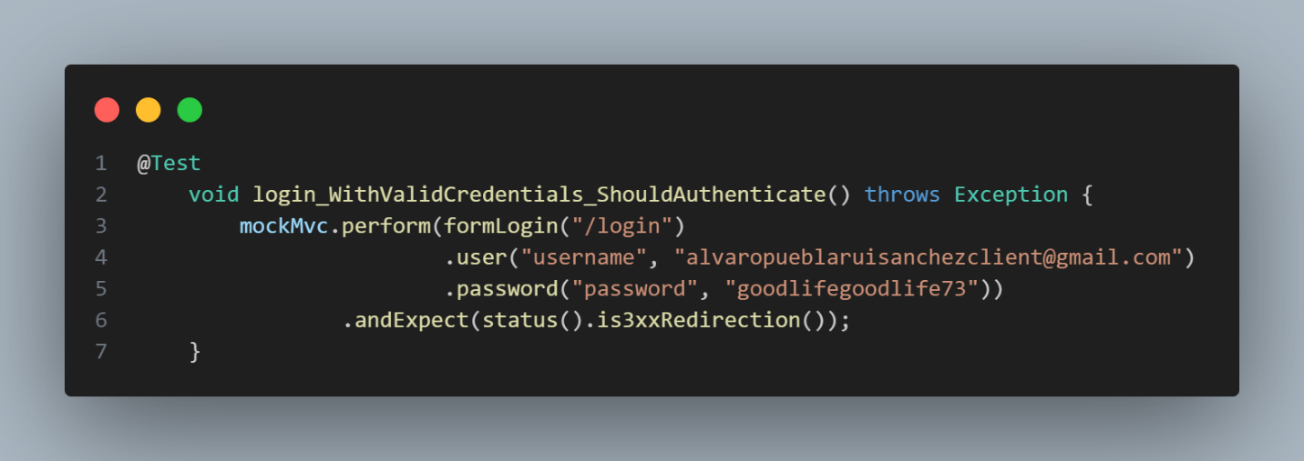
// File: SecurityConfigTest.java

FR-02: Resource Reservation
Test ID | Test Name | Type | Status
FR02-001 | Client can create valid reservation | Automated (Unit) | ✅ Pass
FR02-002 | Overlapping reservations are rejected | Automated (Unit) | ✅ Pass
FR02-003 | End time before start time is rejected | Automated (Unit) | ✅ Pass
FR02-004 | Client exceeding max reservations is blocked | Automated (Unit) | ✅ Pass

Test Case: FR02-002
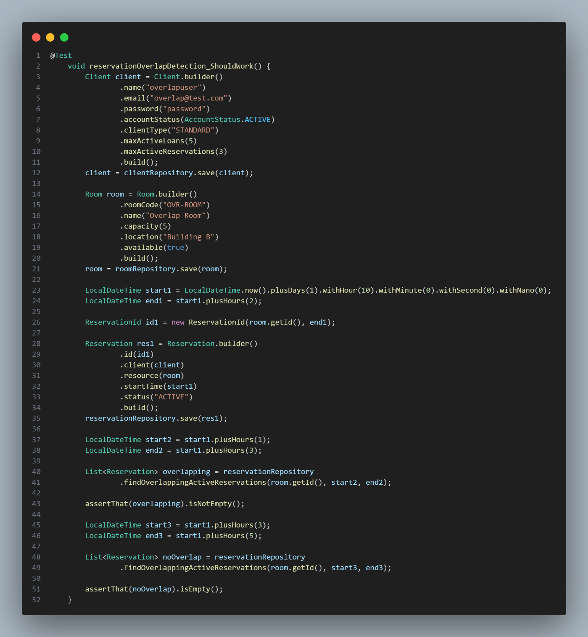
// File: FullIntegrationTest.java

FR-03: QR Code Scanning
Test ID | Test Name | Type | Status
FR03-001 | Valid QR code redirects to resource | Automated (Controller) | ✅ Pass
FR03-002 | Invalid QR code shows error | Automated (Controller) | ✅ Pass
FR03-003 | Missing file shows error | Automated (Controller) | ✅ Pass

Test Case: FR03-001
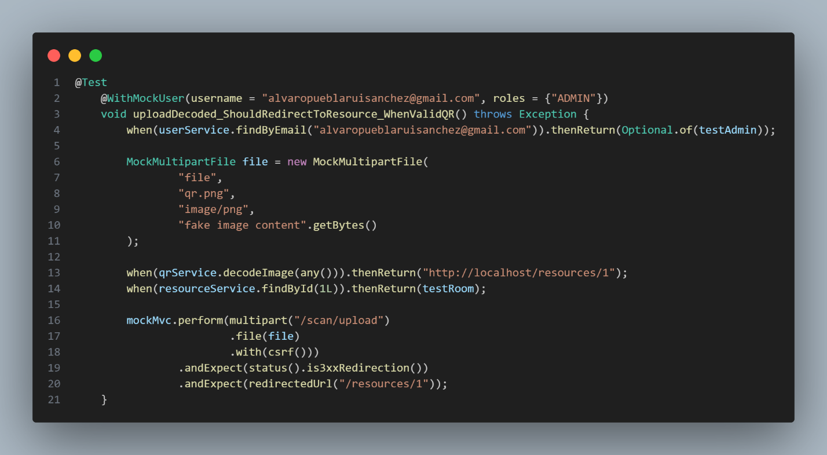
// File: ScannerControllerTest.java

FR-04: Admin Resource Management
Test ID | Test Name | Type | Status
FR04-001 | Admin can create book | Automated (Controller) | ✅ Pass
FR04-002 | Admin can create room | Automated (Controller) | ✅ Pass
FR04-003 | Duplicate ISBN is rejected | Automated (Service) | ✅ Pass
FR04-004 | Admin can delete resource | Automated (Controller) | ✅ Pass

Test Case: FR04-001
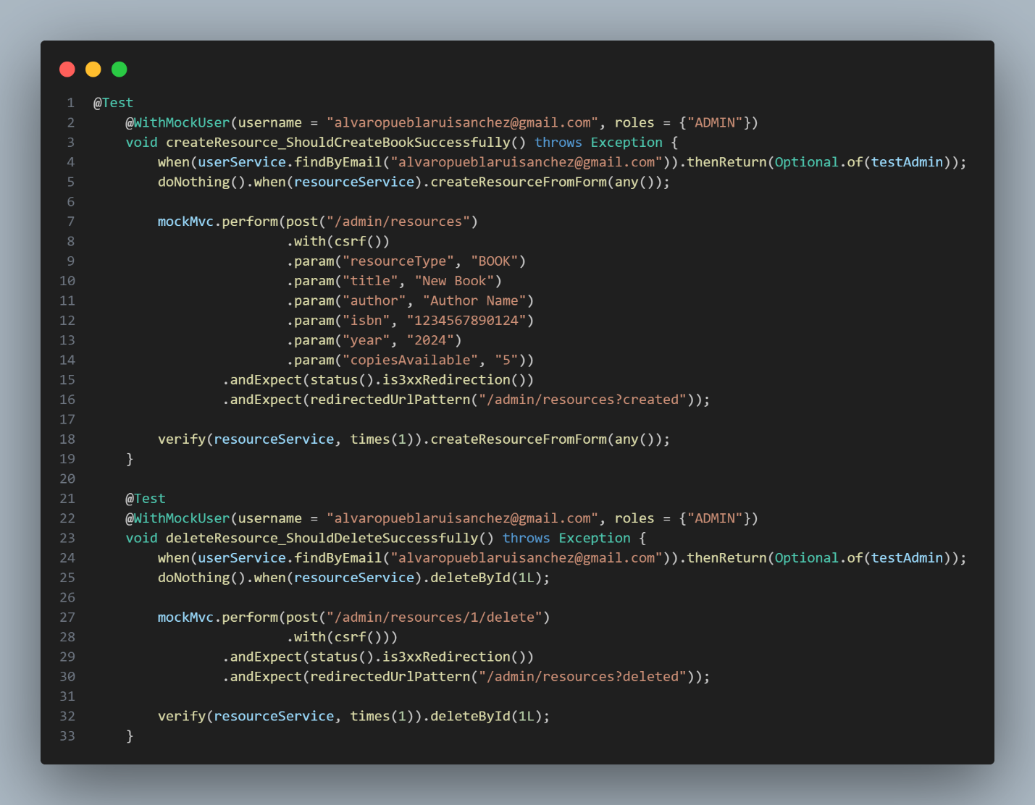
// File:AdminControllerTest.java

      - Non-Functional requirements tests
NFR-01: Security - Authorization
Test ID | Test Name | Type | Status
NFR01-001 | Unauthenticated users redirected to login | Automated (Security) | ✅ Pass
NFR01-002 | Clients cannot access admin endpoints | Automated (Security) | ✅ Pass
NFR01-003 | Admins can access all endpoints | Automated (Security) | ✅ Pass

Test Case: NFR01-002
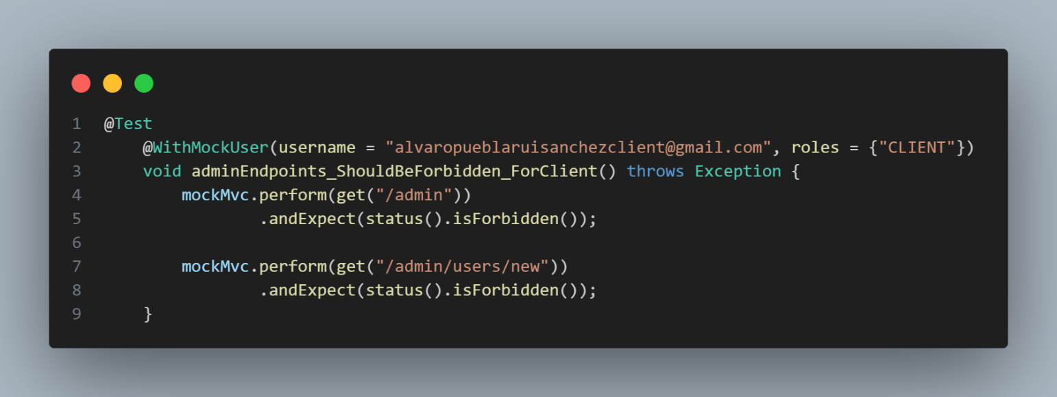
// File: SecurityConfigTest.java

NFR-02: Data Validation
Test ID | Test Name | Type | Status
NFR02-001 | Email format validation | Automated (Unit) | ✅ Pass
NFR02-002 | ISBN format validation | Automated (Unit) | ✅ Pass
NFR02-003 | Capacity must be positive | Automated (Unit) | ✅ Pass

Test Case: NFR02-001
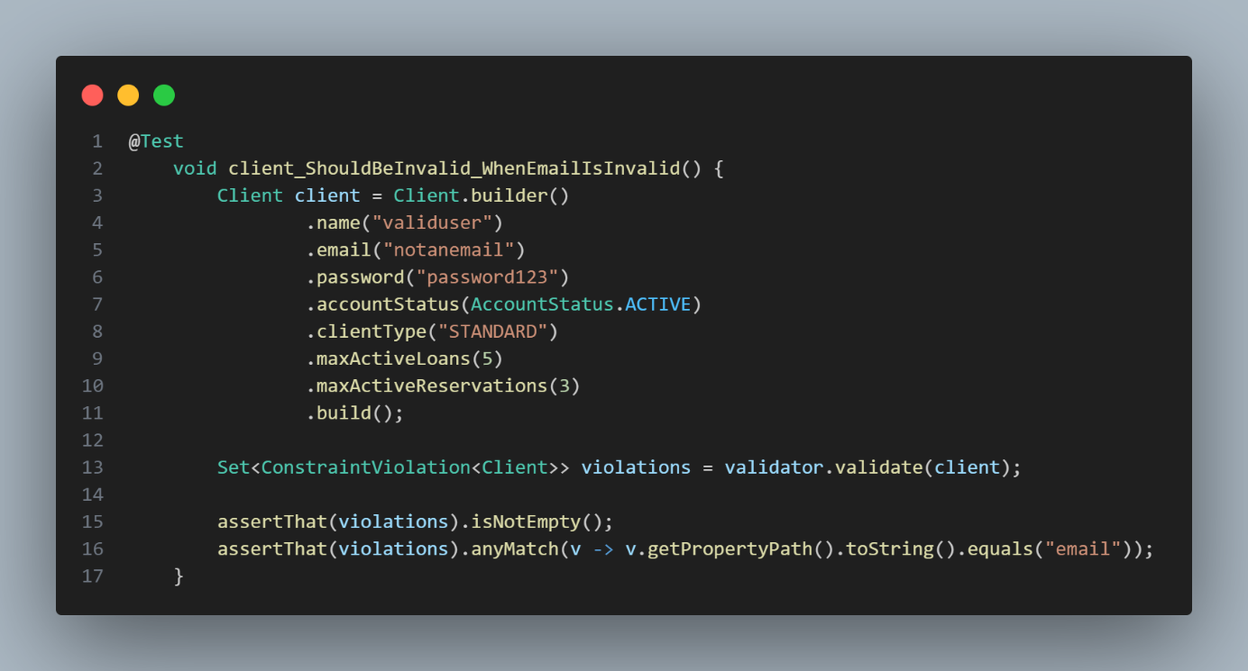
// File: EntityValidationTest.java

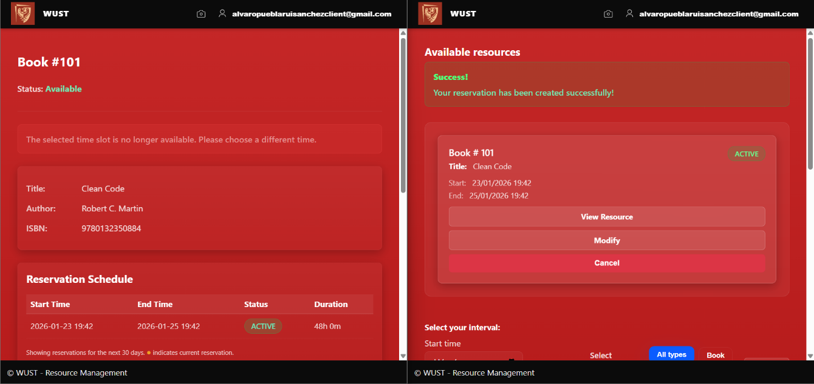
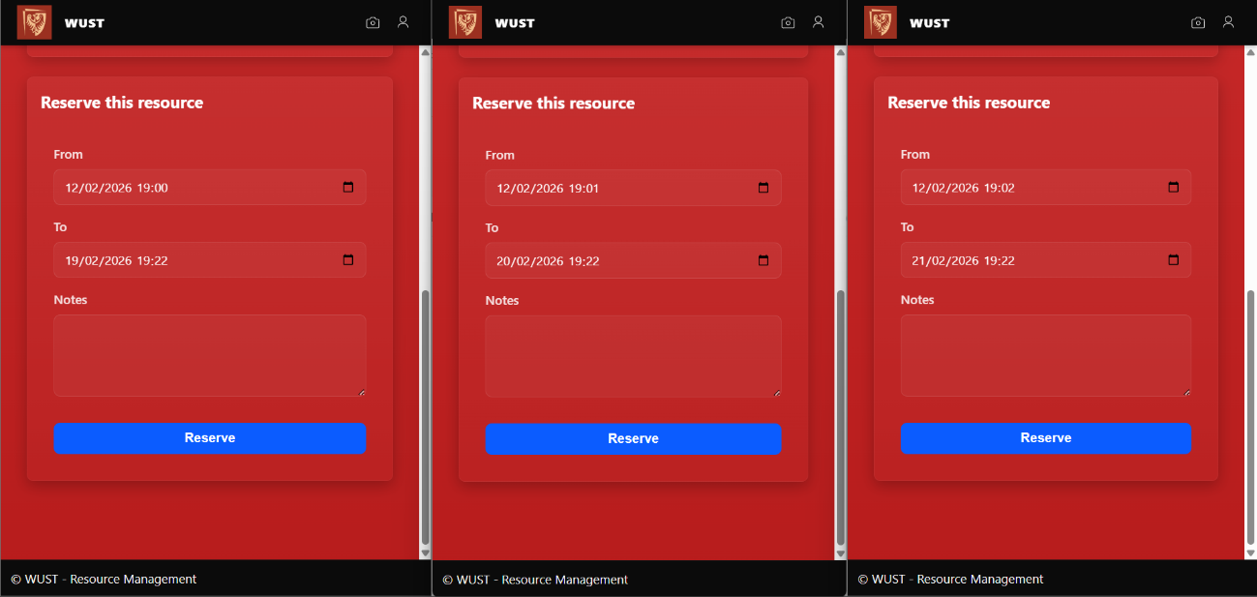
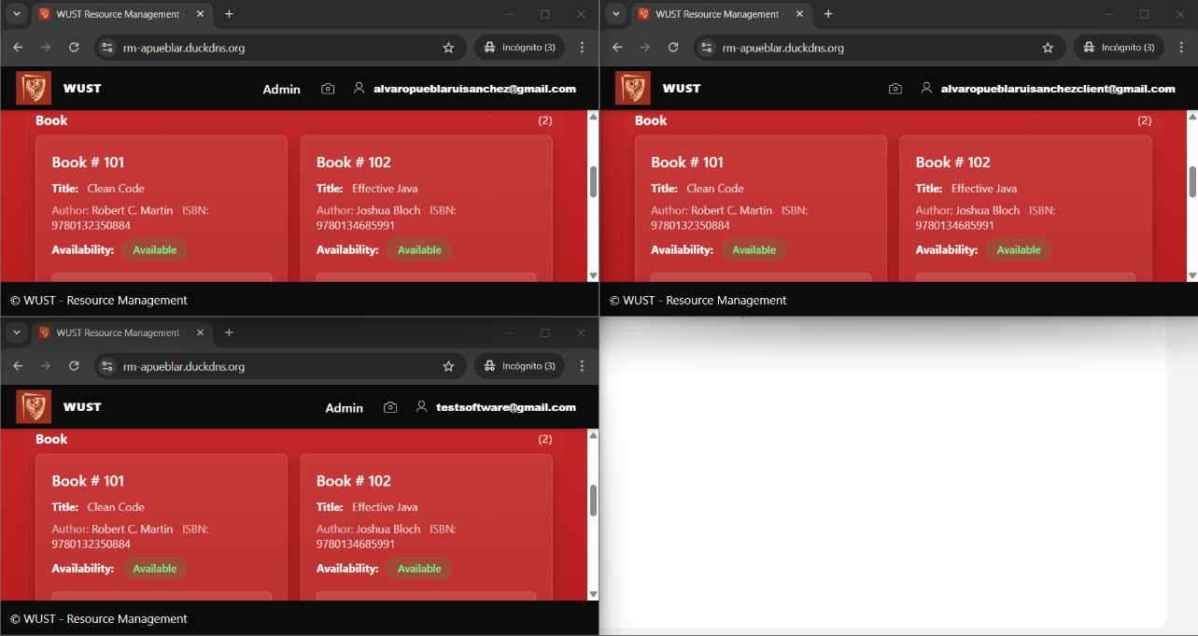
NFR-03: Performance - Concurrent Reservations
Test ID | Test Name | Type | Status
NFR03-001 | Overlapping reservation query < 100ms | Manual (Load Test) | ✅ Pass
NFR03-002 | System handles 3 concurrent users | Manual (Load Test) | ✅ Pass
    - Remaining Tests
If the test plan includes other tests which are not requirements tests, in this section, you can describe them here (e.g., unit tests, integration tests).
Unit Tests:
Entity Validation Tests (18 tests)
EndAfterStartValidatorTest
├── isValid_ShouldReturnTrue_WhenEndTimeIsAfterStartTime
├── isValid_ShouldReturnFalse_WhenEndTimeIsBeforeStartTime
├── isValid_ShouldReturnFalse_WhenEndTimeEqualsStartTime
├── isValid_ShouldReturnTrue_WhenStartTimeIsNull
└── ... (4 more edge cases)

EntityValidationTest
├── client_ShouldBeValid_WhenAllFieldsCorrect
├── book_ShouldBeInvalid_WhenTitleIsBlank
└── ... (8 more validation scenarios)

Service Layer Tests (21 tests)
UserServiceTest (5 tests)
├── findByEmail_ShouldReturnUser_WhenExists
├── findAllClients_ShouldReturnAllClients
└── ...

ResourceServiceTest (5 tests)
├── findById_ShouldThrowException_WhenNotExists
└── ...

ReservationServiceTest (5 tests)
├── createReservation_ShouldSaveReservation_WhenValid
├── cancelReservation_ShouldUpdateStatus
└── ...

QRServiceTest (6 tests)
├── decodeImage_ShouldThrowException_WhenInputIsNotValidImage
├── decodeImage_ShouldSucceed_WhenValidQRCodeProvided
└── ...

Integration Tests:
Repository Layer (9 tests)
RepositoryIntegrationTest
├── userRepository_FindByEmail_ShouldWork
├── reservationRepository_FindOverlapping_ShouldWork
├── resourceRepository_DeleteCascade_ShouldWork
└── ...

End-to-End Workflows (6 tests)
FullIntegrationTest
├── completeUserWorkflow_ShouldWork
├── completeReservationWorkflow_ShouldWork
├── reservationOverlapDetection_ShouldWork
├── cascadeDelete_ShouldWork
└── ...

Controller Tests (29 tests total):
HomeControllerTest (8 tests)
- Authentication redirects
- Resource filtering by time
- User-specific reservation display

ResourceControllerTest (5 tests)
- Resource viewing
- Reservation creation
- Reservation cancellation

AdminControllerTest (10 tests)
- Dashboard access
- User CRUD operations
- Resource CRUD operations

ScannerControllerTest (6 tests)
- QR code upload
- Valid/invalid QR handling
- Error scenarios

Tests Summary:
Layer | Files Tested | Test Count | Status
Entities | 10 | 18 | ✅
Repositories | 7 | 9 | ✅
Services | 4 | 21 | ✅
Controllers | 5 | 29 | ✅
Security | 3 | 10 | ✅
General | All | 6 | ✅
Total | 29 | 93 | ✅

Running All Tests:
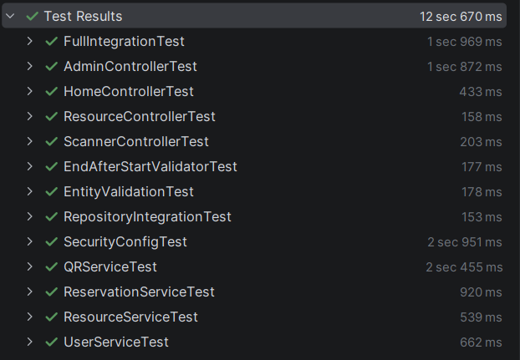

Let’s try the resource management app:
Open: https://rm-apueblar.duckdns.org/
Try the credentials:
User: alvaropueblaruisanchez@gmail.com
Password: goodlifegoodlife73
That is the default admin user.

If you want a default client one use:
User: alvaropueblaruisanchezclient@gmail.com
Password: goodlifegoodlife73

